MR FOUR SQUARE
K FOGARTY 11 – 6 – 12

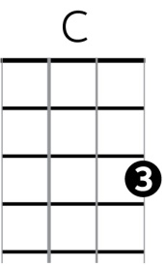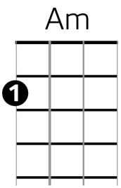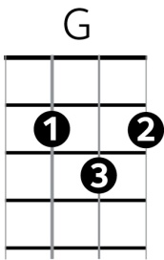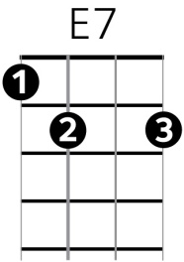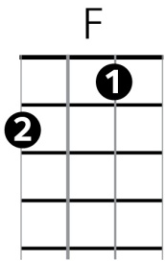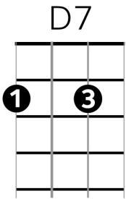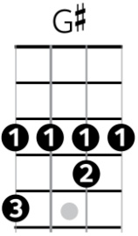

Chorus
C Am G E7 Am
Mr Four Square – the smile we know standing proudly as the four winds blow
F G C Am F G C
To the customer always loyal and true Mr Four Square we love you

Verse 1
E7
We love your Tip top , Jelly top , Peanut-slabs they’re really fab
Am
Crunchies bring the munchies too
D7
Your pineapple lumps are , kind of a - scrumptious
G G# G
Your big ben pies bring a tear to my eyes

Chorus
C Am G
Mr Four Square – the smile we know …..

Verse 2
E7
So many supermarket-mark ups , wanting you to park up
Am
Stack n save n Countaround too
D7
So many big woppas , price droppers , Fridge Breath , More for Less,
G G# G
Old World products with a use-by value

Chorus X2
C Am G
Mr Four Square – the smile we know
E7 Am
Standing proudly as the four winds blow
F G C Am
To the customer always loyal and true
F G C Am
Mr Four Square we love you
F G C
Mr Four Square thumbs-up to you. [ Poo-poopy-do ]

